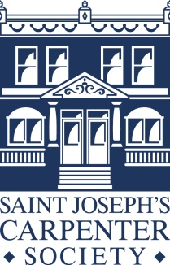

**Saint Joseph’s Carpenter Society**

**Mission Statement**

Saint Joseph’s Carpenter Society strives to improve the quality of life of the people of the City of Camden and its surrounding communities by promoting affordable housing and neighborhood development. Through our initiatives, we encourage people to take charge of their lives and become active community members.

**General Overview**

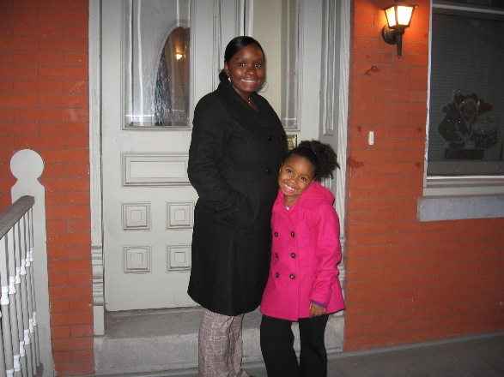 Saint Joseph’s Carpenter Society of Camden, New Jersey was founded in 1985 to help families improve their quality of life and create safe neighborhoods through homeownership. SJCS holds that homeownership leads to a higher quality of life by encouraging stability, fostering personal pride, promoting the development of community ties, allowing families to build wealth, and attracting private capital to under-invested areas. To promote successful homeownership, SJCS performs three interrelated functions: community organizing, housing development, and homeowner education. SJCS’s primary work involves targeting abandoned homes for acquisition, rehabilitation and sale to neighborhood families.

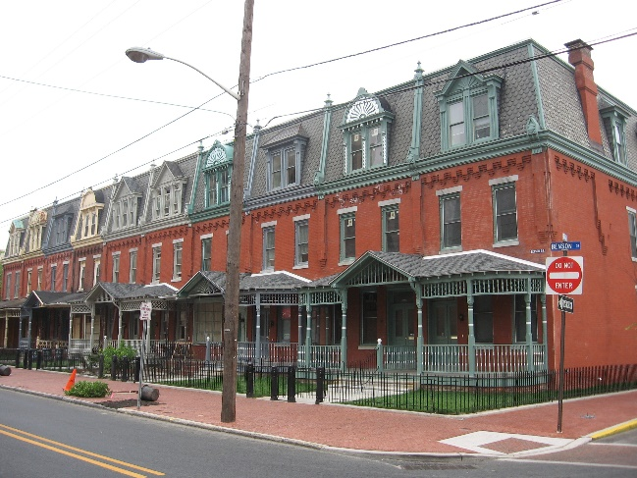 After creating housing opportunities in the City of Camden for several years, the Society realized that if neighborhoods were to be reborn, our rehabilitated homes needed to house financially responsible and informed community members. This realization led to the creation of the *Homeowner Academy* in 1994. The 4-week *Financial Capability* and 4-week *Homebuyer Education* courses, mandatory for all SJCS homebuyers, teach families the basics of financial management and of the mortgage process, 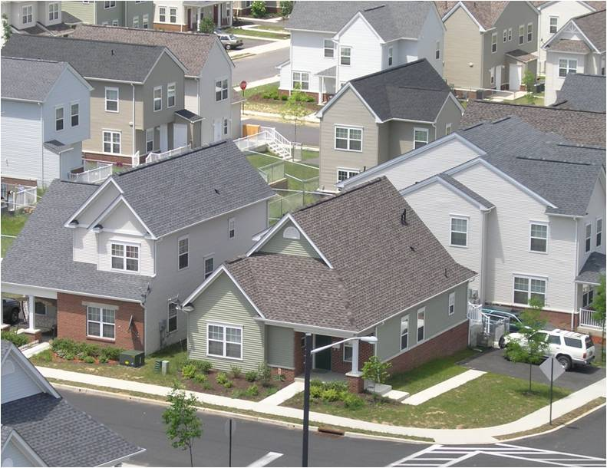as well as the responsibilities of being home-owning community members. Attending these group education sessions, as well as private one-on-one counseling session, empowers clients to qualify for mortgages to purchase a completely renovated or newly built house.

Our educational offerings don’t stop at homebuying education or financial capability. Our Maintenance Lab is a series of workshops aimed to improve maintenance of a person’s homes. Most of the workshops are interactive, allowing residents to learn how to install a toilet or repair a faucet at a hands-on approach.

A key element of SJCS’s neighborhood redevelopment model is community engagement to form networks capable of addressing local concerns. Becoming involved in the community is encouraged of all new homeowners to play an active role in the upkeep and development of their neighborhoods and has now led to SJCS being involved in the asset development of the neighborhood as a whole, including parks, safe intersections, diverse community events, and a bustling commercial corridor.

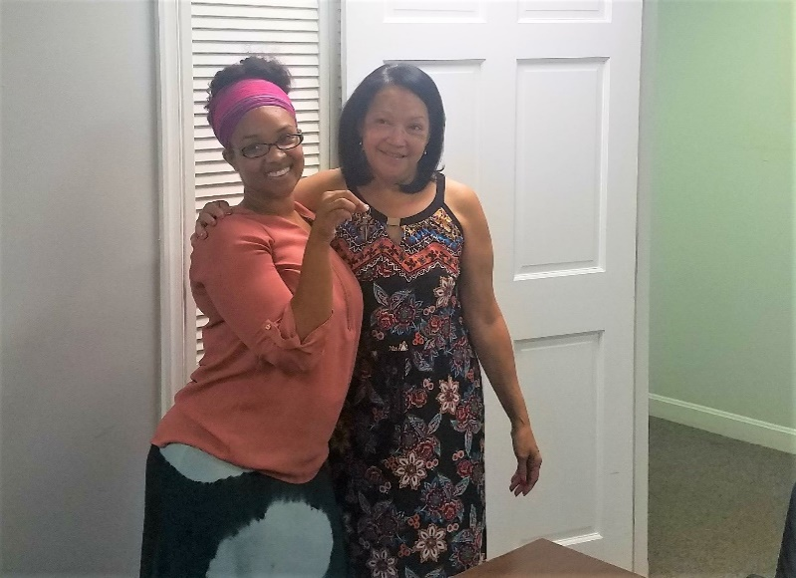

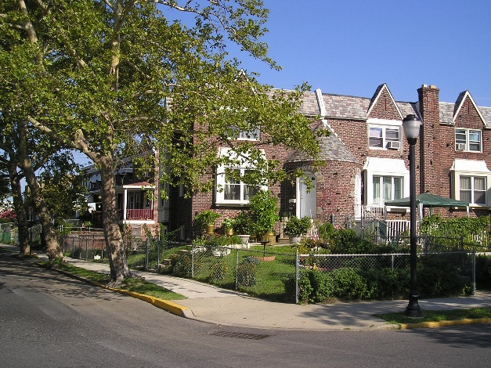 SJCS’s three-phased approach to community development is stabilizing the local housing market. To date, SJCS has developed 1,000 residential properties in targeted neighborhoods. Over 680 of these have been homeownership. This includes LIHTC projects, both in the role of developer as well as co-developer, gut rehabilitation of formerly abandoned properties, and new construction on vacant lots. In addition, SJCS has offered repairs to 450 residents of Camden through the Camden Home Improvement Program, the myHOME program, façade improvement programs, and the NJDCA Lead Remediation Pilot Program. In 2017, SJCS worked with 383 clients. 148 individuals graduated from the *Homeowner Academy* with 172 people attending the classes. Typical homebuyers are African American, Hispanic, and Asian. Typical household annual incomes are $20,000 to $35,000. The value of SJCS homes has risen dramatically: in 1990 rehabilitated homes sold for $20,000; today these homes sell for between $72,000 and $150,000. 85% of all SJCS homes sold are still owned by original Carpenter Society buyers or their families and the mortgage foreclosure rate is only 4%. The fact that SJCS’s homes are appreciating and that families are successful homeowners are strong endorsements of SJCS’s community development approach.

SJCS is a NeighborWorks America Chartered Member and a certified HUD Counseling Agency with the Housing and Community Development Network of New Jersey Intermediary.

**Resumes**

A brief description of the staff follows:

*Executive Director*

Pilar Hogan Closkey, PE, PP, AICP joined the Carpenter Society in 1998 as the Operations Manager and, in 2004, was named the Executive Director. Ms. Closkey graduated from the University of Notre Dame with a B.S. in Civil Engineering and worked for seven years in the field of consulting engineering. Ms. Closkey then pursued her Master’s degree in Regional Planning at the University of North Carolina – Chapel Hill and worked for a non-profit tax credit developer. She is a licensed Professional Engineer in Illinois and New Jersey, a licensed Professional Planner in New Jersey, and is nationally certified with the American Institute of Certified Planners. As the Executive Director, Ms. Closkey reports to the Board of Trustees and is responsible for the day-to-day activities of the Society.

*Director of Accounting and Administration*

Tracy Dinh joined the Carpenter Society in November 2003. She is a magna cum laude graduate of Temple University with a B.A. in Business, Accounting major. She then pursued her MBA at Holy Family Univerity. She spent the previous two years as an accountant at the Kimmel Center and prior to that worked as accountant/office manager for Urban Consultant’s Inc. in Philadelphia. Ms. Dinh is responsible for all financial matters for the Carpenter Society and is Vietnamese/English bilingual.

*Project Manager*

Enrique Rivera joined SJCS in April 2017 and directs affordable housing development and neighborhood revitalization efforts. Mr. Rivera graduated with a Masters in community and regional planning from Temple University and has worked at Cooper’s Ferry Partnership in the City of Camden. Mr. Rivera is Spanish/English bilingual and has worked extensively in East Camden on neighborhood initiatives including the My East Camden Plan, park planning and programming, and commercial corridor surveying and improvements.

*Development Coordinator*

Richard Kochanski joined the Carpenter Society in 2006. Mr. Kochanski is a graduate of LaSalle University. He spent the previous nine years in the Alumni Office of LaSalle University. He works on issues related to donor relations and special events. Rich will be retiring in 2019.

*Development Coordinator*

           Alison Cieslik joined the Carpenter Society in 2019 to step into the position that Rich held.  Ms. Cieslik is a graduate of Lehigh University and Rutgers School of Law-Camden.  She spent the previous ten years in fundraising and event planning.  She works on issues related to donor relations, communications and special events.

*Director of Counseling*

Rosie Figueroa is a Neighborhood Housing Reinvestment Institute certified mortgage counselor and is Spanish/English bilingual. She holds a B.A. in Social Work from Rutgers University, Camden. As Senior Mortgage Counselor, Ms. Figueroa directs the preparation of all applicants for home purchase which includes credit and pre-purchase counseling. She is also available for post-closing counseling, as necessary. She came to the Carpenter Society in 1991 after working in international private banking and funds management.

*Director of Education*

James Roche directs the Education department and the operations of its programs. He is also responsible for acquisitions activities. Mr. Roche joined the Society in 1994 after 20 years of pastoral ministry. He holds an M.A. in Education from Iona University and a B.A. from St. Mary’s College, Baltimore, MD. He is certified by the Delaware Valley Mortgage Plan as a mortgage counselor and by the American Homeowner Education and Counseling Institute.

*Project Manager*

Tracy Bell joined the Carpenter Society in late 2001 and now is the Construction Manager. Mr. Bell holds a B.S. in Industrial Technology and Engineering from Cheyney University of Pennsylvania. He worked in the commercial construction field for the previous 15 years.

*Intake Specialist*

Marisol DiFrancesco joined the organization in July 2018 as an intake specialist for our home repair programs. Ms. Di Francesco is bilingual in both English and Spanish. She holds a certification from Rutgers-Camden in case management. Previously, she worked for Catholic Charities as a case manager.

*Prroject Coordinator*

Mariana Hinojosa joined St. Joseph’s Carpenter Society in July 2017. She holds a B.S. in Fashion Management from Philadelphia University. As Office Coordinator, Ms. Hinojosa provides support to the Administration and Counseling Departments at the organization. Prior to joining the Carpenter Society, she worked for 4 years at other non-profit organizations in the City of Camden; first as an office manager for a community organizing organization, and later at a small business development association doing administrative and marketing work. Ms. Hinojosa is bilingual in Spanish/English.

*Construction Director*

Michael Welde joined the Carpenter Society in 1999 after having worked for us as a sub-contractor since 1996. Mr. Welde holds a Bachelor’s degree from Villanova University. He worked as a self-employed general contractor prior to his work with the Carpenter Society. Mr. Welde is responsible for a carpentry crew and their sub-contractors.

*Carpenter*

James Herman has been a Carpenter on our Construction team since 2001. After graduating from Haddonfield High School, Mr. Herman enlisted in the U.S. Army, training at Fort Dix, NJ, and Fitzsimmons Army Hospital in Denver, Colorado, in the repair of hospital equipment. He also served in Bangkok, Thailand. He has been in the construction field ever since his discharge from the Army.

*Carpenter*

Joseph Ramos joined our Construction team in 2004 as a laborer and is working to improve his carpentry skills. Mr. Ramos is Spanish/English bilingual.

*Receptionist*

Iveliz Porrata joined our team in 2019 as a receptionist. She is responsible for answering and transferring phone calls, helping with office administration and greeting people at the front door. Ms. Porrata is English/Spanish bilingual.