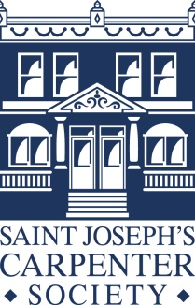**Overview**

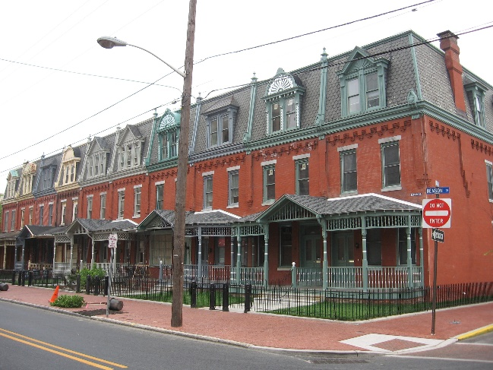Saint Joseph's Carpenter Society (SJCS) was founded in 1985 to help local families improve their quality of life and create safe neighborhoods, building assets to invest in themselves at the same time as investing in the neighborhood. Using homeownership as a goal to assist families in their pursuit of financial stability and improved quality of life provides a wealth-creation-based model of urban renewal for inspiration and replication. Its core mission is to target abandoned and very poor condition homes for selective acquisition, gut rehabilitation, and sale to neighborhood families. To do this, SJCS has historically utilized a three-phased redevelopment model of financial education, neighborhood revitalization, and community engagement, under the guidance of market-based development and neighborhood planning. SJCS works from areas of health to stabilize the community while also slowly raising the market value of SJCS homes. This combination has resulted in an increased market valuation of the overall target neighborhood, not just SJCS homes. The investment has created a vibrant retail environment, with Federal Street becoming the best commercial corridor in the City, and East Camden becoming a neighborhood of choice.

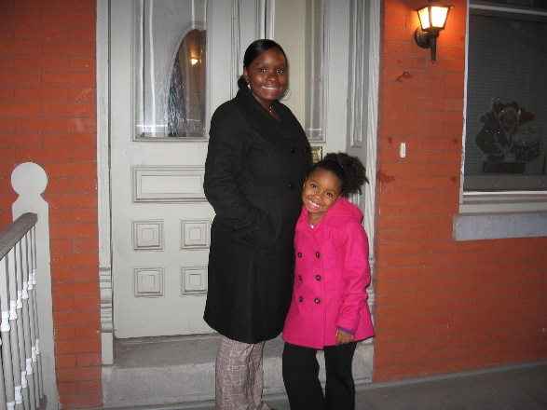It is the people that make the community. So, while improving the overall housing condition of the neighborhood, SJCS works to prepare buyers to be responsible and informed community members. SJCS is a HUD certified housing counseling agency requiring both one-on-one housing counseling and education group classes. The series of classes teaches families the basics of financial management and the mortgage process, as well as the responsibilities of being home-owning community members. The private counseling sessions are designed to assist clients with credit, income, and savings issues that may have been identified. SJCS staff is involved throughout the entire process, all the way through mortgage application and closing. This intensive relationship building is maintained, and an open-door policy allows any client to return with questions in the future. To date, SJCS has educated over 7,000 participants with over 3,400 graduating from the Homeowner Academy.

Neighborhood revitalization is then the next step. SJCS has created over 1,000 homes for families and offered repairs to an additional 550 homeowners. The vast majority of these clients are located in East Camden resulting in the landscape of East Camden changing dramatically. With a foreclosure rate of 4% of residents who purchased a home through SJCS and an 84% homeownership retention rate describing the percentage of homeowners who still own their homes over the past 35 years, SJCS has also reduced the building vacancy rate of East Camden to be between one-half and one-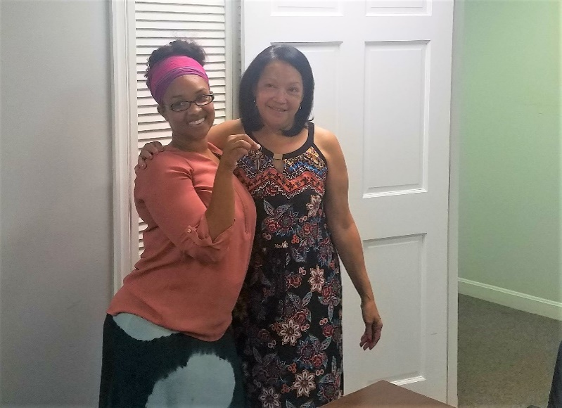quarter of the rest of the city. This noticeable improvement in the condition of East Camden has led SJCS to include community stabilization and resident engagement in its mission. While housing remains the key focus for the agency, SJCS is now also involved in neighborhood-based initiatives to leverage the housing investments. This overwhelming success story is a testament to the completeness of the model and the readiness of clients to be homeowners, investing in their own lives as well as the future of Camden simultaneously.

SJCS is also now engaged in housing production outside of East Camden. SJCS is working to bring its learnings in East Camden to other communities. SJCS is active in other neighborhoods within the City of Camden but is also partnering with various municipalities in South Jersey to reduce the existence of abandoned housing and bring life back to these zombie houses with families.

SJCS is a NeighborWorks America Chartered Member rated as exemplary and a certified HUD Counseling Agency with the Housing and Community Development Network of New Jersey Intermediary.

**Board of Trustees**

Saint Joseph’s Carpenter Society has an active Board of Trustees. The Board is a diverse governing entity that includes men and women dedicated to the SJCS mission bringing different perspectives to each meeting. SJCS is qualified as a CHDO (Community Housing Development Organization) and is required to have one-third of its Board membership be people representative of its communities. The Board has completed the Excellence in Governance Program and has prioritized diversity, equity, and inclusion for both its membership and governance as well as that of the entire organization.

**Resumes**

A brief description of the staff follows:

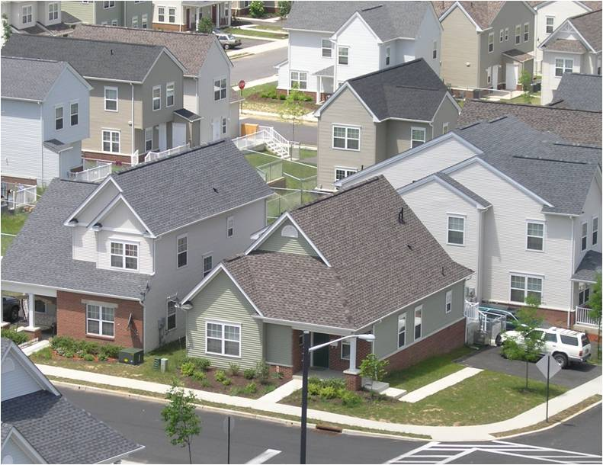*Executive Director*

Pilar Hogan Closkey, PE, PP, AICP joined the Carpenter Society in 1998 as the Operations Manager and, in 2004, was named the Executive Director. Ms. Closkey graduated from the University of Notre Dame with a B.S. in Civil Engineering and worked for seven years in the field of consulting engineering. Ms. Closkey then pursued her Masters degree in Regional Planning at the University of North Carolina – Chapel Hill and worked for a non-profit tax credit developer. She is licensed as a Professional Engineer and a Professional Planner in New Jersey and is nationally certified with the American Institute of Certified Planners. As the Executive Director, Ms. Closkey reports to the Board of Trustees and is responsible for the day-to-day activities of SJCS.

*Director of Accounting and Administration*

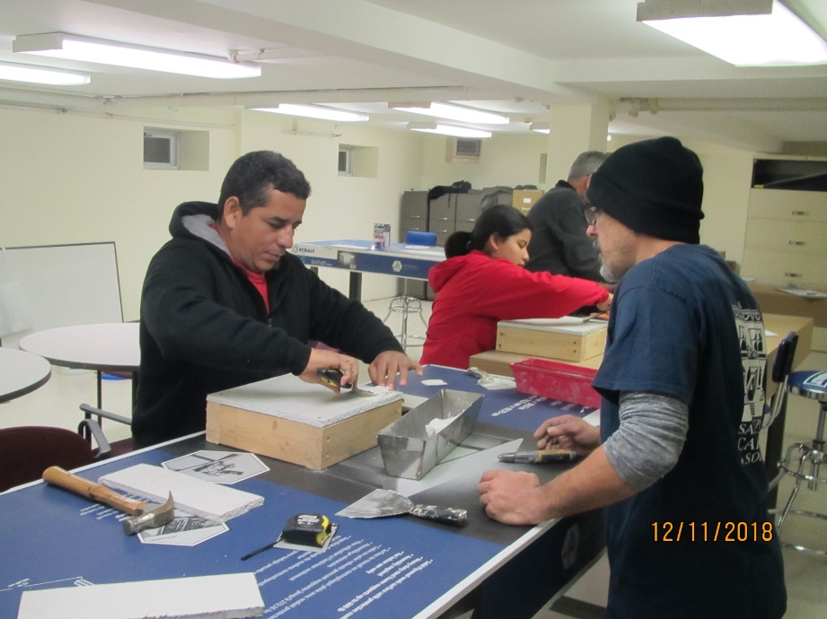Tracy Dinh joined the Carpenter Society in November 2003. She is a magna cum laude graduate of Temple University with a B.A. in Business, Accounting major. She then pursued her MBA at Holy Family University. She spent the previous two years as an accountant at the Kimmel Center and prior to that worked as accountant/office manager for Urban Consultant’s Inc. in Philadelphia. Ms. Dinh is responsible for all financial matters for the Carpenter Society and is Vietnamese/English bilingual.

*Director of Neighborhood Development*

Enrique Rivera, PP, AICP joined SJCS in April 2017 and directs affordable housing development and neighborhood revitalization efforts. Mr. Rivera graduated with a Masters in community and regional planning from Temple University and has worked at Cooper’s Ferry Partnership in the City of Camden. Mr. Rivera is Spanish/English bilingual and has worked extensively in East Camden on neighborhood initiatives including the My East Camden Plan, park planning and programming, and commercial corridor surveying and improvements. He is licensed as a Professional Planner in New Jersey and is nationally certified with the American Institute of Certified Planners.

*Director of Counseling*

Rosie Figueroa is a HUD certified mortgage counselor and is Spanish/English bilingual. She holds a B.A. in Social Work from Rutgers University, Camden. As Senior Mortgage Counselor, Ms. Figueroa directs the preparation of all applicants for home purchase which includes credit and pre-purchase counseling. She is also available for post-closing counseling, as necessary. She came to the Carpenter Society in 1991 after working in international private banking and funds management.

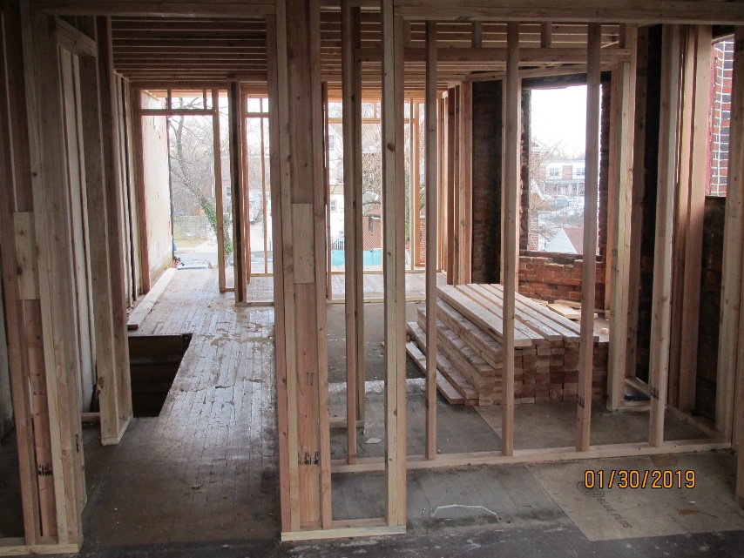

*Housing Counselor and Education Coordinator*

Sandra Walden officially joined SJCS in July 2021 and has been facilitating the Spanish speaking Homeownership classes since 1999.  She received the Neighbor Works Train the Trainer certification in 2003.   Sandra has worked as a Project Development Manager and Property Management Director for the Diocesan Housing Services of the Diocese of Camden, Inc. from 2004 – 2015.   Sandra is the Housing and Education Coordinator for SJCS and is responsible for assisting the Director of Counseling with the applicants for home purchase.

*Project Manager*

Tracy Bell joined the Carpenter Society in late 2001 and now is the lead Project Manager for all construction related issues. Mr. Bell holds a B.S. in Industrial Technology and Engineering from Cheyney University of Pennsylvania. He worked in the commercial construction field for the previous 15 years.

*Assistant Project Manager*

*Development Coordinator*

Alison Cieslik joined the Carpenter Society in 2019 Ms. Cieslik is a graduate of Lehigh University and Rutgers School of Law-Camden.  She spent the previous ten years in fundraising and event planning.  She works on issues related to donor relations, communications, and special events.

*Director of Community Impact*

Soley Berrios joined SJCS in July 2021 as a lifelong East Camden resident who grew up in a SJCS home. She graduated from Rowan University with a Bachelor of Communication and was featured in Rowan’s Magazine Fall 2019 issue in their *Under 40 & Overachieving* article. She is well versed in different nonprofit sectors and city affairs. She is Spanish/English bilingual.

*Community Engagement Specialist/Social Services*

Erica Acevedo works part-time in Community Engagement and part-time in Social Services. She joined SJCS in November 2019 after working in rental social services for Ingerman Management. She is English/Spanish bilingual.

*Intake Specialist*

Iveliz Porrata joined the organization in August 2020 as a part-time intake specialist for our home repair programs. Ms. Porrata is bilingual in both English and Spanish and had previously worked as a receptionist for SJCS. She is currently pursuing her degree in Social Work.

*Construction Director*

Michael Welde joined the Carpenter Society in 1999 after having worked for us as a sub-contractor since 1996. Mr. Welde holds a Bachelor’s degree from Villanova University. He worked as a self-employed general contractor prior to his work with the Carpenter Society. Mr. Welde is responsible for a carpentry crew and their sub-contractors.

*Carpenter*

Joseph Ramos joined our Construction team in 2004 as a laborer and is working to improve his carpentry skills. Mr. Ramos is Spanish/English bilingual.

*Property Manager*

Cherise Harris joined the Carpenter Society to lead up the property management team in January 2020. She had worked on the SJCS portfolio for Ingerman Management Company prior to joining the Carpenter Society. Ms. Harris is a Certified Occupancy Specialist (C.O.S.) and also has her Assistant Housing Manager (A.H.M.) certification for Public Housing and is certified as a Tax Credit Specialist.